Oaxaca

Restaurant Management System (ARMS)

Design Document

# Overview

Each of the below views are purely mock-up designs and are not intended to look like the final version of the program; however, the features that they contain meet the user story requirements, and will thus be included in the final version of the program.

# Customer View

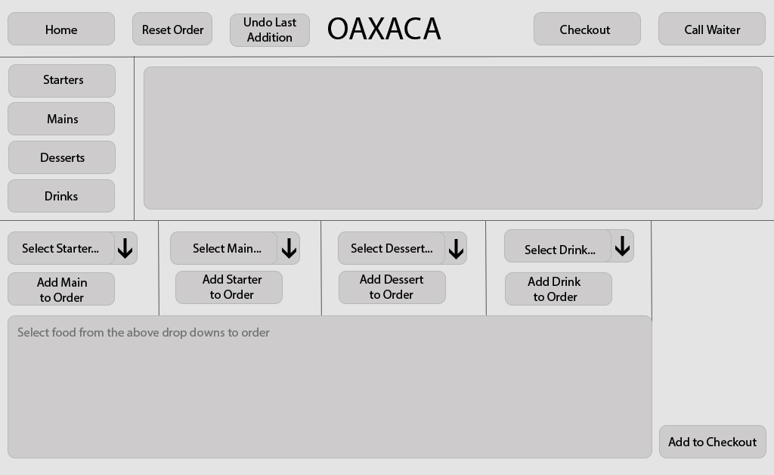

The Customer view consists of a single view which is shown above. The customer has the ability to view the menu with the top half of the screen by selecting the category of the menu that they wish to view, and then once they’ve made a decision on which food they would like to order, they can select that food using the drop-down boxes below. If the user makes a mistake when adding a food item, they’re able to undo the last addition to their order by using the ‘Undo Last Action’ button. The user is also able to reset their order using the ‘Reset Order’ button located near the top left.

When the user has finished choosing the food for their order, they’re able to add the food in the bottom box to the checkout using the button in the bottom right. They’re then able press the ‘Checkout’ button in the top right to finish their order.

If the customer needs assistance, they’re able to click the ‘Call Waiter’ button in the top right, which will alert their allocated waiter that they need assistance.

The ‘Home’ button takes the user back to the very beginning of the program, meaning when the user initially runs it

# Waiter Views

Main Area (after successfully logging in)

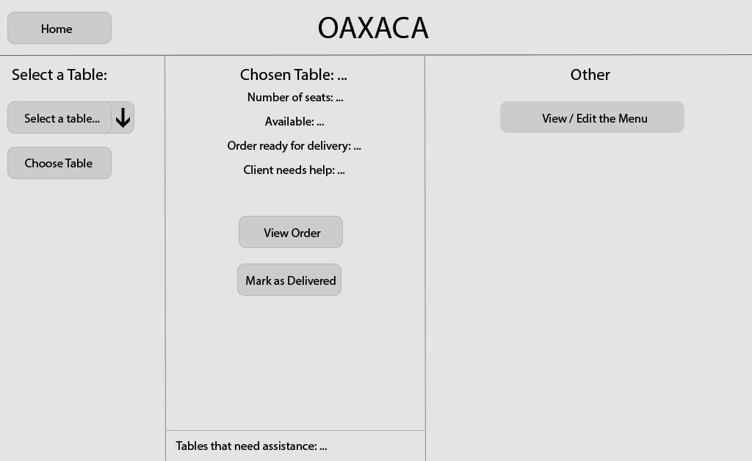

The above is the screen that the waiter will see upon successfully logging in with their credentials. The waiter will be able to select a table to serve by selecting a table with the drop-down box to the left of the screen.

In the middle of the screen then, the waiter will be able to see the number of seats that the table has, whether its available, whether their order is ready for delivery, or whether they need assistance. The waiter will also be able to view the selected tables order, along with being able to mark their food order as delivered when collecting from the kitchen.

To the right of the screen, the waiter is able to edit the menu by clicking the ‘View / Edit the Menu’ button, which allows them to add and remove food from the menu.

Change the menu

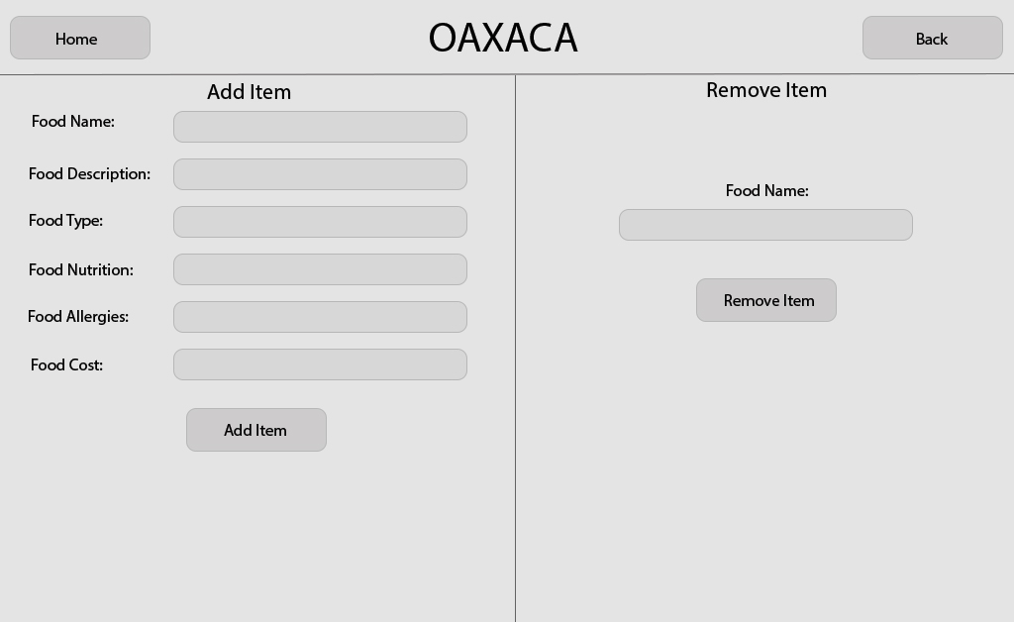

On this page, the waiter is able to add or remove items from the menu.

If the waiter wanted to add an item to the menu, they would have to input data into all of the fields, then press the ‘Add Item’ button.

If the waiter wanted to remove an item from the menu, all they would need to do is input the food name of that item, and then press the ‘Remove Item’ button.

Depending on what the user presses, a message will be displayed at the bottom of the page informing them whether that adding the item to the menu was successful or not, and the same for removing an item.

The ‘Home’ button takes the user back to the very beginning of the program, meaning when the user initially runs it, and the ‘Back’ button takes the user back to the main Waiter area.

Order Confirmation & Editing Order

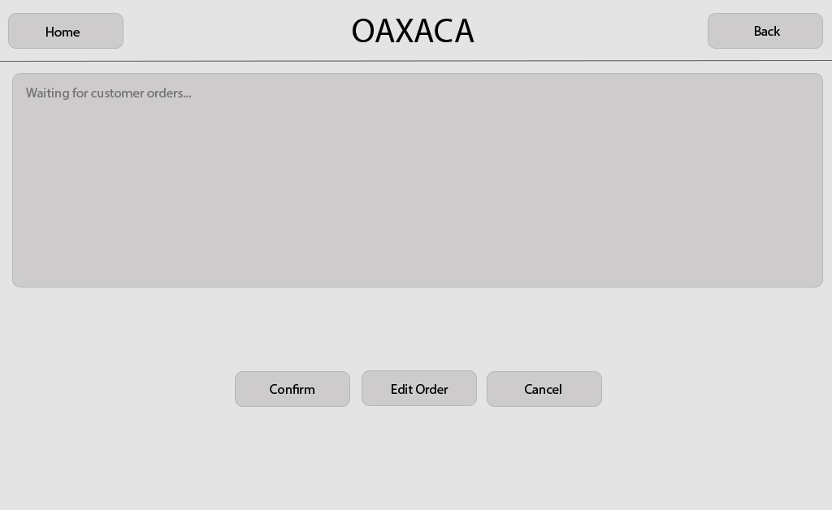

When the client has selected a table and that table has placed their order and successfully checked it out, the waiter can access this screen by viewing that tables order. If the table made a mistake when ordering, then the waiter is able to edit their choices (e.g. if the customer wanted a plain burger) by clicking the ‘Edit Order’ button.

The waiter is also able to confirm the customers order so that it can get sent through to the kitchen staff for them to cook by simply clicking the ‘Confirm’ button.

If the ‘Cancel’ button is pressed, then the waiter will cancel the customers order, and free up the table for the next group of people that entire the restaurant.

The ‘Home’ button takes the user back to the very beginning of the program, meaning when the user initially runs it.

# Kitchen View

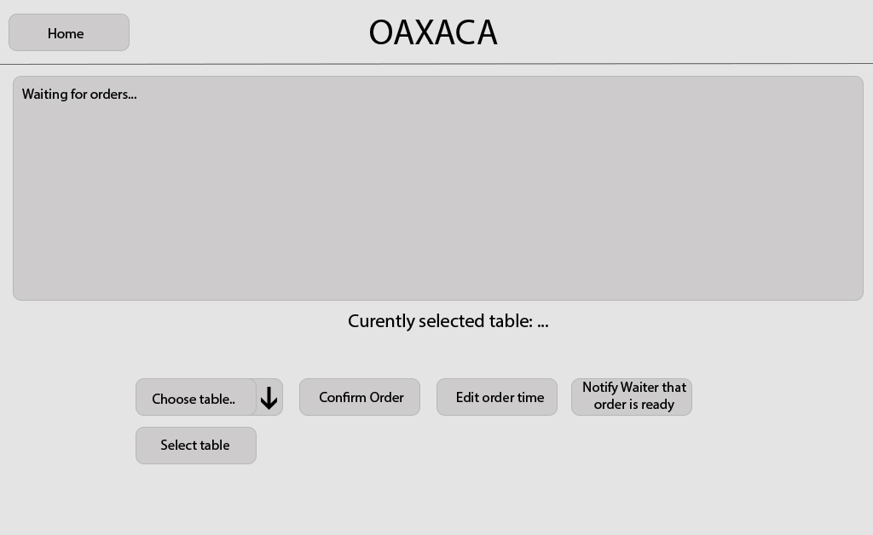

The kitchen view will display every order that they have received from the waiter (meaning once it has been confirmed by the waiter), along with the table that the order is for.

The kitchen staff are then table to choose a specific table from the dropdown box, press ‘Select Table’ and then are able to confirm that the order is currently being cooked by pressing ‘Confirm Order’.

The kitchen staff can edit the order time of the order for the currently selected table by pressing the ‘Edit order time’ button.

The waiter can inform the waiter that one of their tables orders is ready by pressing the ‘Notify Waiter that order is ready’ button.

The ‘Home’ button takes the user back to the very beginning of the program, meaning when the user initially runs it.